**­­­­­­­­REACT ROUTER**

Is the process of resource navigation in a web app. This is how your app determines what to do with a client request. For example:

Routing is a process in which a user is directed to different pages based on their action or request. React JS Router is mainly used for developing Single Page Web Applications. React Router is used to define multiple routes in the application. When a user types a specific URL into the browser, and if this URL path matches any 'route' inside the router file, the user will be redirected to that particular route

**INSTALLATION STEPS FOR ROUTER IN REACT**

Step 1: Installing React Router. To install React Router, you'll need Node.js installed for the npm command line tool, after which you have to run the following command: npm install react-router-dom....

Step 2: Adding React Router.

Step 3: Routing and Rendering Components.­

Steps to create router in react

Step1:- Open Visual Studio. Go to file and select open folder.

Step2:- Open my-react app.

Step3:- Go to sre and create a new file. Give name as Home.js, about.js and contact.js.

Step4: Then go to App.js

Step5:- Then compile each file in App.js

Step6:- Save all files and execute App.js in new terminal type and run npin start.

Step7:- In browser output is displayed.

File1.Home.js

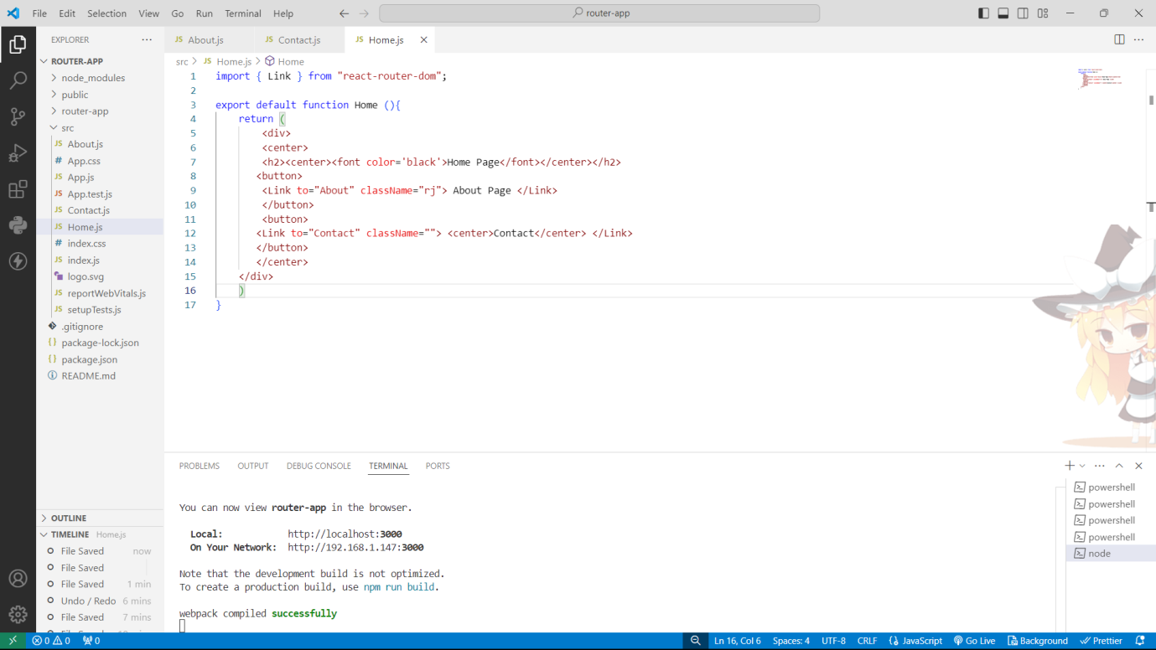

File2.About.js

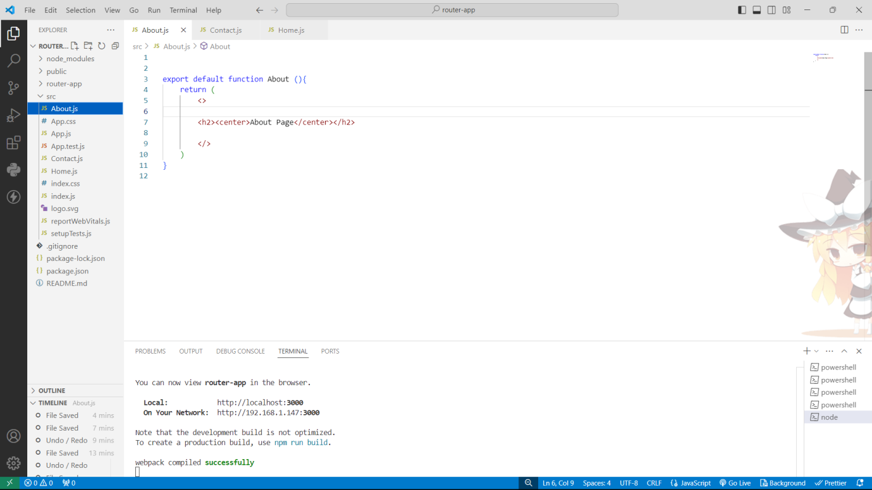

File 3.Contact.js

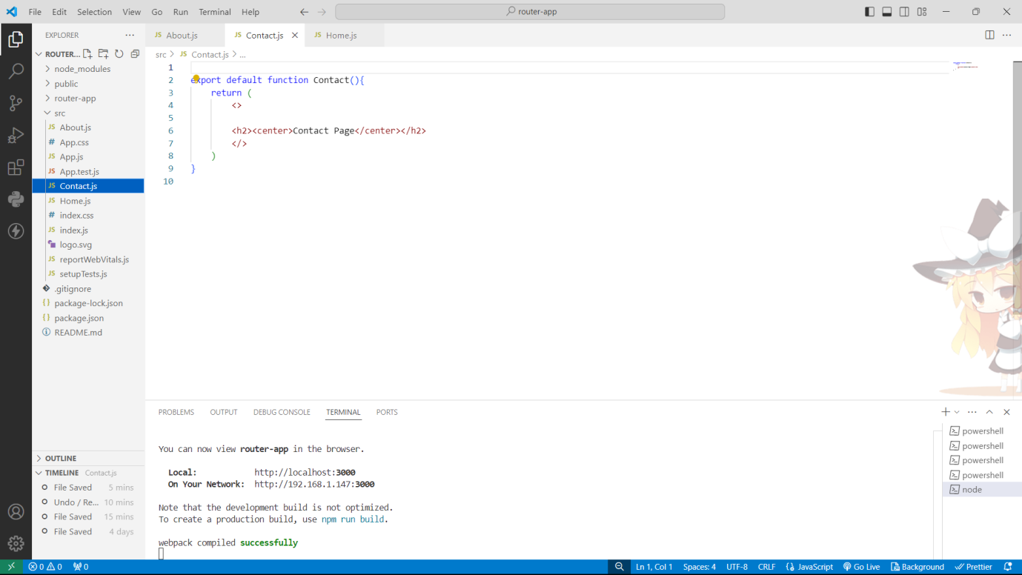

File 4.App.js

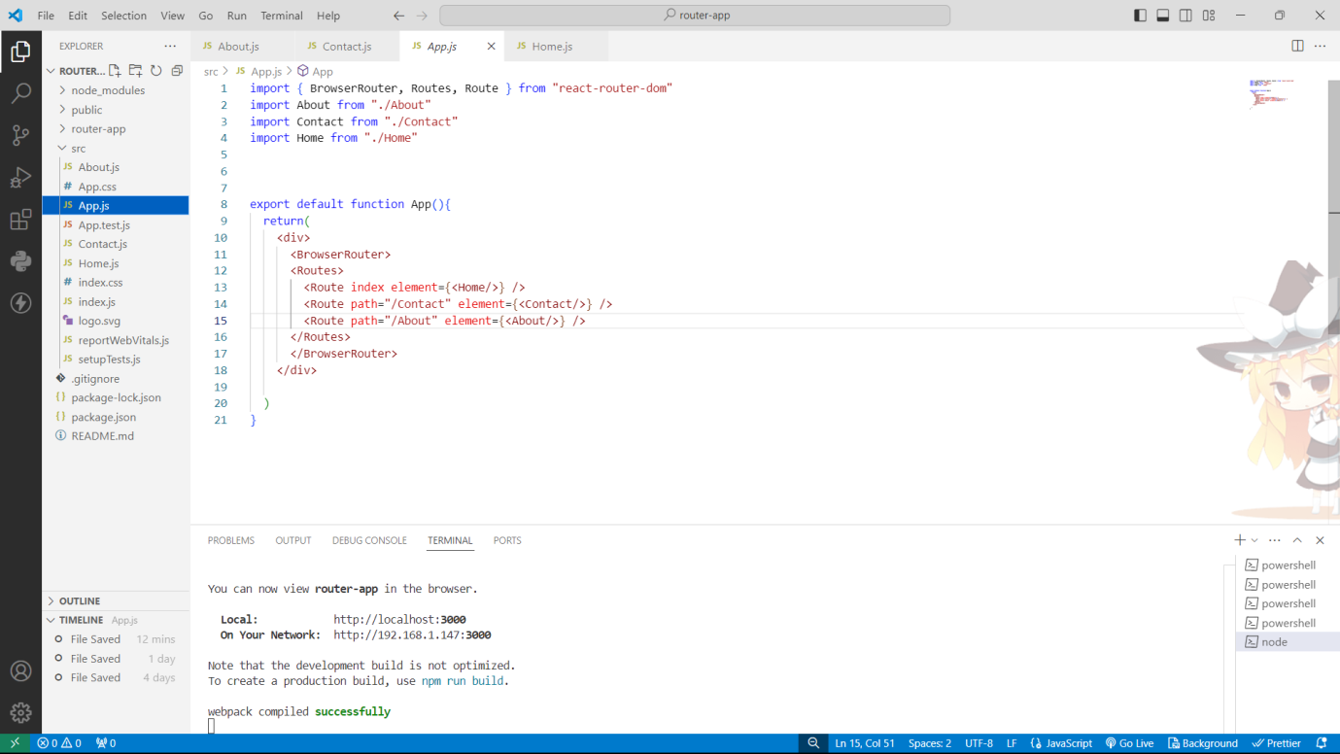

**OUTPUT :-**

